Training: Qt Framework
Workbook
(edition 1.1, November, 2016)

Training: Qt Framework
The authors: | Yuriy Dvorzhetskiy (YDvorzhetskiy@luxoft.com)
Product version: | Qt 5.7  Qt Creator 4.1.0

Exercise Specifications

Virtual Machine Properties
IMAGE_SOURCE_LOCATION
VM_NAME
GUEST_OS_TYPE
GUEST_OS_RAM
GUEST_LOGIN
GUEST_PASS

Exercise 1
Working with Qt Creator

Duration
20 min

Objectives
Learn how to create, build, run and debug console and GUI Qt applications with Qt Creator.

Description
Qt Creator is cross-platform IDE to develop Qt applications. With Qt you can do full stack of development operations – create, build, run, test and debug Qt projects.

Tasks
- Create your first Qt console application, understand project sources structure. Build your application, understand generated files structure. Run your application.
- Create your first Qt GUI application, understand project structure, forms files. Build your application, understand generated files structure. Run your application.

Detailed guidelines

Part 1: Creating first Qt console application.
- Launch Qt Creator.
- Click to this menu item to create project:
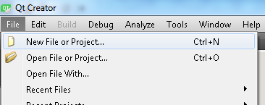
- Select “Qt console application” and press “Choose…” button:
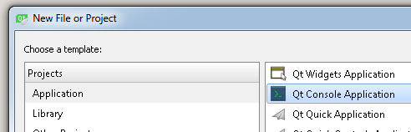
- Specify your project location and compiler and press “Finish” button.
- What sources have been created? What content of main.cpp file? What class is used?
- What settings are in .pro file? What Qt modules are used in project?
- Run qmake. This operation is required when you add new .cpp file for some compilers:
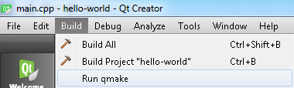
- See in project folder, what files are generated?
- Build your project. There are three ways to do it:
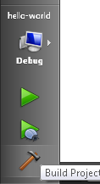
or using menu
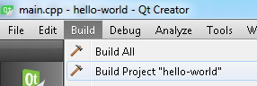
or using shortkut “Ctrl + B”.
- See in project folder, what files are generated?
- Run your project:
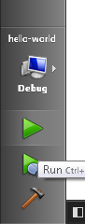
or using menu
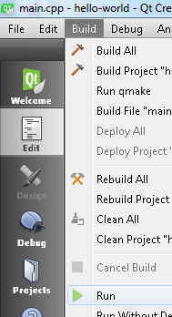
or using shortkut “Ctrl + R”.
- What has been displayed? Why application does not stop?

Part 2: Creating first Qt GUI application.
- Click to this menu item to create GUI project:
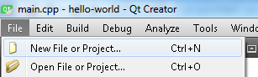
- Select “Qt Widgets Application” and press “Choose…” button:
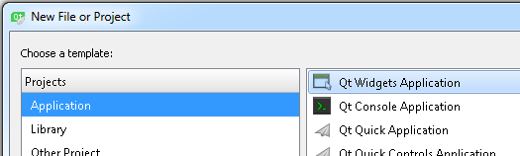
- Specify your project location and compiler and click “Choose…” button.
- See what settings are added to widget application?
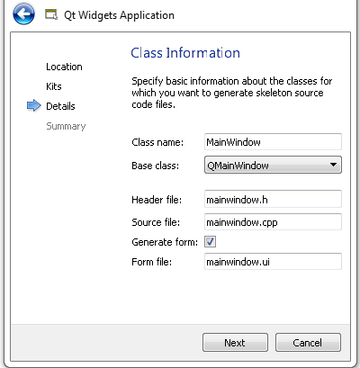
- Approve default settings by clicking “Next” button.
- What sources have been created? What content of main.cpp file? What classes are used?
- Open mainwindow.ui form in Qt Designer. See what you can do with form and it’s controls.
- Open mainwindow.ui form in editor. What you can say about this form?
- Open mainwindow.h. What is the syntax of this file? What new keywords are present?
- Open mainwindow.cpp. Why constructor has parent argument?
- Build your project. What files are generated in project folders? What is moc_* file?
- Run your project.
Exercise 2
Creating QObjects hierarchy

Project
qt-02-qobject

Duration
1 hour

Objectives
Understand QObject structure, its naming and hierarchy mechanisms.

Description
QObject is a common parent for most Qt classes. Your classes must be inherited from QObject. QObject provides common mechanisms such naming, hierarchy, slots and signals. QObjects has special structure and syntax. To develop Qt applications you must familiar with QObject structure and syntax.

Tasks
- Create your class “Human” derived from QObject with:
- the age int-field.
- the sex symbol
- Create hierarchy of humans that represents real family tree:
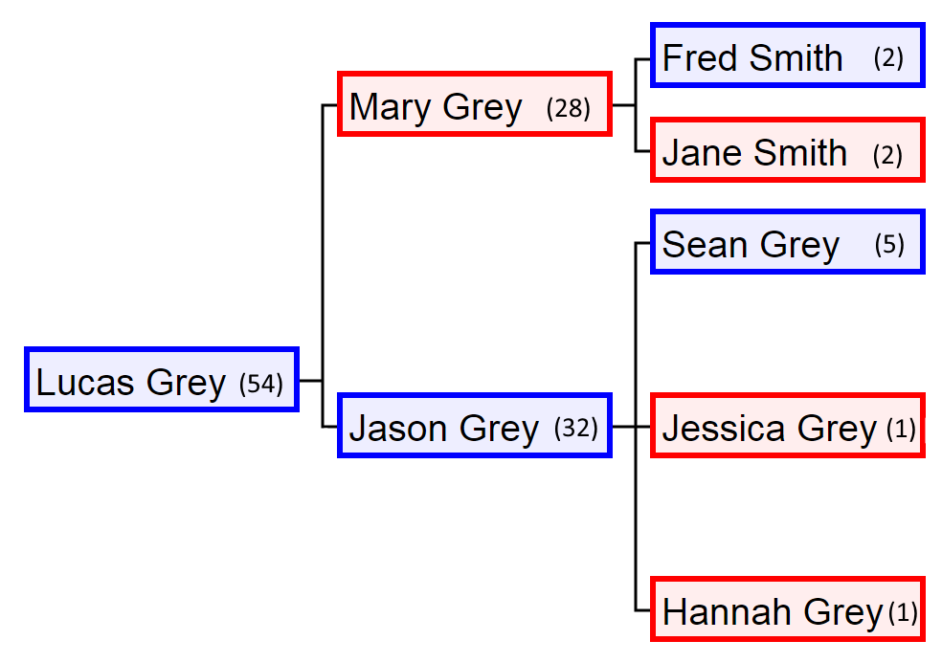
- Print information about objects using dumpObjectTree() method.
- Write function to print information about this tree as the tree of QObject* using qobject_cast and call this function for your hierarchy.

Detailed guidelines

Part 1: Creating “Human” class.
- Open the labs/qt-02-qobject project.
- Create new class Human using Qt wizard:
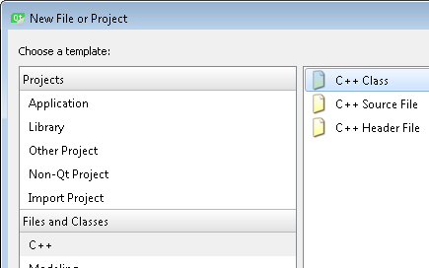
- Define a class name, file paths and add tell wizard that QObject is the base class.
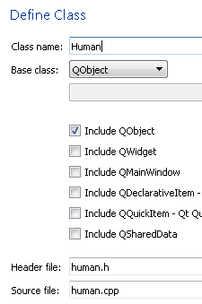
- What code is generated?
- What you need to add? What name of the field you suggest? What names should have the getter and the setter of this field?
- Add to class declaration the private field int m_age, getter age() and setter setAge(int).
- Add to class declaration the private field char m_sexSymbol, getter sexSymbol() and setter setSexSymbol(char).
- Implement all getters and setters.
- Add #include "human.h" to main.cpp file.

Part 2: Objects hierarchy.
- Create objects hierarchy. There shoud be something like:
Human *parent = new Human;
parent->setObjectName("Lucas Grey");
parent->setAge(54);
parent->setSexSymbol('M');
Human *maryGrey = new Human(parent);
maryGrey->setObjectName("Mary Grey");
maryGrey->setAge(28);
maryGrey->setSexSymbol('F');
- Why we don’t set children to the parent object?
- Delete hierarchy at the end of the main function. What object we have to delete? What objects will be deleted automatically?

Part 3: Dump objects tree.
- Dump objects tree with parent->dumpObjectTree(); method.
- What fields are not displayed? How to print other fields?
- Run your program. Check your hierarchy.

Part 4: Write your own tree printing.
- In functions argument you have QObject* pointer – cast it to the human:
Human* human = qobject_cast<Human*>(parent);
- Why qobject_cast is used?
- Print information about parent. You can have something like:
qDebug() << parent->objectName()
<< "age:" << human->age()
<< "sex:" << human->sexSymbol();
- Why we don’t need separators? What will be displayed if you call qDebug() for each field?
- Print information about children:
for (int i = 0; i < human->children().length(); ++i) {
printTreeInfo(human->children().at(i));
}
- What is the type of this children list? Why we do recursive call for?
- Run your program, check your output.
Exercise 3
Containers and QString

Project
qt-03-containers-and-qstring

Duration
1 hour

Objectives
Learn Qt containers, container-like structures and QString.

Description
Qt provides its own convenient containers to store any data types. There are some container-like structures with the same behavior. QString is very useful Qt Unicode string used in most classes.
In project you have the list with names.

Tasks
- Using Java-style iterators print the longest name from the list. Use QString::arg to output message with this name.
- Using STL-style iterators print the shortest name from the list. Use QString::prepend and append to output message with this name.
- Using foreach and QStringList show all names with "lynn" suffix and print it separated by ',' as one string.
- (optional) Print all names in reverse order: using QStack, using other QList and without other containers.

Detailed guidelines

Part 1: The longest name with Java-style iterators and QString::arg.
- Open the project qt-03-containers-and-qstring;
- Java-style iterators looks something like:
QListIterator<QString> javaIterator(names);
- Write an iterator declaration.
- What methods are available in this iterator? How to use them?
- Iterate the list with this iterator:
while(javaIterator.hasNext()) {
QString currentName = javaIterator.next()
// ...
}
- Add your logic to find the longest name.
- Print the longest name using QString::arg:
QString output("Longest name: %1");
qDebug() << output.arg(longestName);

Part 2: The shortest name with STL-style iterators and QString::prepend
- Iterate list with STL-style iterator:
for (QList<QString>::iterator i = names.begin();
i != names.end(); ++i) { ... }
- How to use this iterator?
- Add your logic to find the shortest name.
- Output the shortest name using QString::prepend method:
qDebug() << shortestName.prepend("Shortest name: ");

Part 3: Retrieving the context from xml file.
- You can simply iterate your containers using foreach:
foreach (QString name, names) { ... }
- Create QStringList and add all names from the names list.
- What methods are in QStringList?
- You can output this construction using:
qDebug() << namesList.join(',');

Part 4 (optional): Print all names in reverse order.
- Try to do it by yourself. You can see solution in solutions directory.
Exercise 4
Signals and slots

Project
qt-04-signals-and-slots

Duration
1 hour

Objectives
Learn signals and slots mechanism.

Description
Qt provides powerful mechanism – signals and slots.
In this exercise you have Bank class. BankAccount objects are children of the Bank object. Bank object must be notified about all changes in bank accounts. The Logger class is used to output all changes.

Tasks
- Implement all required methods and declare required signal in BankAccount class.
- Connect all bank accounts to the logger, add and test all connectivities.
- Connect bank to the logger, add and test all connectivities.
- Declare and implement all required slots and signals in Bank class.

Detailed guidelines

Part 1: BankAccount
- Open the project qt-04-signals-and-slots
- What sources are already written? What objects are created in the main function? Why we do not delete objects in the main function?
- Open bankaccount.h file. What methods are declared? What is needed? What signature of the signal do you want specify?
- Declare signal signature.
void balanceChanged(long newBalance);
- Open bankaccount.cpp file. What methods are implemented? Why there is no needed signal implementation? What is needed to implement?
- Implement all required methods, use setBalance to emit required signal.
emit balanceChanged(newBalance);
- Build and application. What do see? What need to show information about accounts?

Part 2: Connecting BankAccount objects to the logger
- Open main.cpp. What objects are need to be connected?
- Connect objects:
QObject::connect(
account1, &BankAccount::balanceChanged,
&logger, &Logger::logAccountChange
);
- Why you need to specify QObject:: prefix?
- Run application. What do you see now? How to print the total bank balance?

Part 3: Connecting the Bank object to the logger.
- Connect the Bank object to the logger:
QObject::connect(&bank, &Bank::totalBalanceChanged,
&logger, &Logger::logTotalBalance);
- Build and run application. Why information about changing the total bank balance is not printed? What have to be done?
Part 4: Implementing Bank slots and signals
- Open the bank.h file. What is needed?
- Declare slot to notify about account operations (all accounts will be connected to this slot):
void updateTotalBalance();
- And implement it. This slot must emit the Bank::totalBalanceChanged signal.
Use getter Bank::totalBalance:
void Bank::updateTotalBalance() {
emit totalBalanceChanged(totalBalance());
}
- Run your application. Why information about changing the total bank balance is not printed?
- Open bankaccount.cpp and connect accounts to the bank at creation time:
connect(this, SIGNAL(balanceChanged(long)),
parentBank, SLOT(updateTotalBalance()));
- Why we don’t need QObject:: prefix here?
- Run your application. Check that all notifications are shown. In what order they are displayed?

Exercise 5
GUI widgets

Project
qt-05-gui-widgets

Duration
2 h

Objectives
Learn how to use Qt Widgets module and create GUI applications.

Description
Qt provides a cross-platform functionality to create rich GUI applications. In this exercise you will create simple bank application.

Tasks
- Create empty GUI application. Configure the window title
- Create GUI widgets:
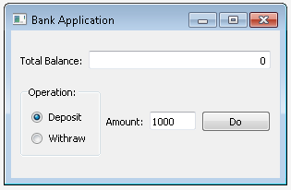
- Add BankAccount class
- Integrate BankAccount class with your GUI.
- (optional) improve widgets settings for the best look.

Detailed guidelines

Part 1: Creating after advices.
- Open Qt Creator, create Qt Widgets Application.
- Specify main widget parameters and create project.
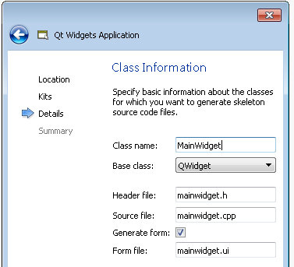
- Open created mainwidget.h, mainwidget.cpp and main.cpp. What is in these files? What lines create and show the window?
- Run application. Why the direct child from QWidget has a title and a frame? What is the title of the window?
- Open mainwidget.cpp. Specify the window title in the constructor:
this->setWindowTitle("Bank Application");
- Run application and check result.

Part 2: Adding Qt Widgets.
- Open mainwidget.ui in Qt Designer.
- Add two Horizontal Layouts on the form using a drag-and-drop from the left Toolbox:
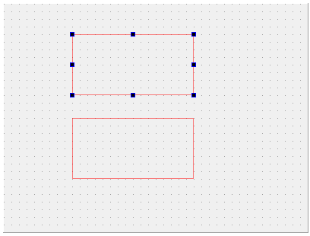
- Add the text label and the line edit to the first horizontal layout for total bаlance dispalaying:
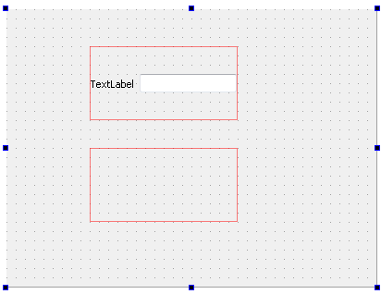
- Add Group Box, Text Label, Line Edit and Push Button:
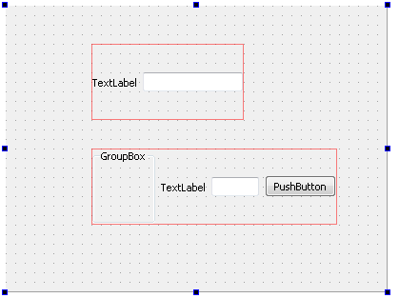
- Add radio buttons:
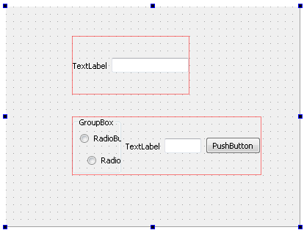
- All widgets should be aligned. Try to align radio buttons in the group box. You can add layout directly to the widget. Do a right click on the group box and select vertical layout:
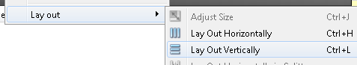
And you will get something like:
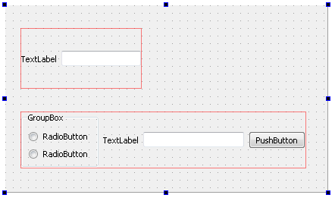
- Do the same with the main widget:
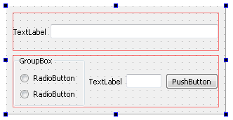
- Change widget’s labels. This can be done with property window at the right of IDE or through double-click on widget, or by press F2 on a selected widget:
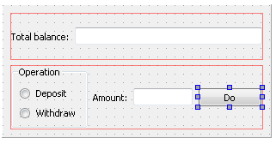
- Check first radio button using properties window.
- Run your application. Check your widgets.
- Open mainwidget.h and mainwidget.cpp. Where are all controls?
- Let’s set names to objects:
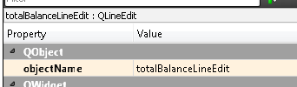
- total balance line edit: totalBalanceLineEdit;
- deposit radio button: depositRadioButton;
- withdraw radio button: withdrawRadioButton;
- amount line edit: amountLineEdit;
- operation button: operationPushButton.

Part 3: Adding BankAccount class.
- You can simply copy BankAccount class from previous exercise. Or write it again.
- Add new class using Qt Creator.
- Add following signals and slots:
signals:
void balanceChanged(long newBalance);
public slots:
void deposit(long amount);
void withdraw(long amount);
private:
long m_balance;
- Add new class using Qt Creator.
- Add following code:
public:
explicit BankAccount(QObject *parent = 0);
void deposit(long amount);
void withdraw(long amount);
long balance() const;
signals:
void balanceChanged(long newBalance);
private:
long m_balance;
- Implement it.

Part 4: Integrate UI to BankAccount class.
- First, you have to create BankAccount object to integrate. Let’s do it in main function:
MainWidget w;
BankAccount *account = new BankAccount(&w);
account->setObjectName("account");
- Why we create bank account with parent?
- Create slot in MainWidget class to update info from the bank account:
public slots:
void updateInfo();
- And implement it. Access to account and line edit using find method:
void MainWidget::updateInfo() {
BankAccount *account
= findChild<BankAccount *>("account");
long balance = account->balance();
QLineEdit *totalBalanceLineEdit
= findChild<QLineEdit *>(
"totalBalanceLineEdit"
);
totalBalanceLineEdit->setText(
QString::number(balance)
);
}
- You can also add this method call into the main function to display initial state of the account:
MainWidget w;
BankAccount *account = new BankAccount(&w);
account->setObjectName("account");
w.updateInfo();
w.show();
- Do a right-click on operation push button and connect to the signal clicked():
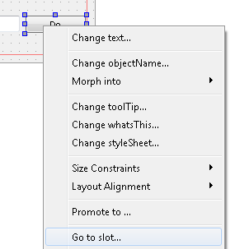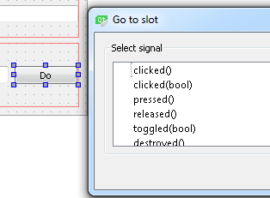
- Check that new slot has been created. Here you can implement deposit/withdraw behavior.
- Implement it:
QString amountText
= findChild<QLineEdit *>(" amountLineEdit")
->text();
BankAccount *account
= findChild<BankAccount *>("account");
long amount = amountText.toLong();
if (findChild<QRadioButton *>("depositRadioButton")
->isChecked()) {
account->deposit(amount);
}
if (findChild<QRadioButton *>("withdrawRadioButton")
->isChecked()) {
account->withdraw(amount);
}
- Run your application. Why the total balance does not change?
- Connect the bank account to MainWidget:
QObject::connect(
account, &BankAccount::balanceChanged,
&w, &MainWidget::updateInfo
);
- Run your application. Check that all work.

Part 5 (optional): Improving UI.
- Make totalbalanceLineEdit right-aligned and non-editable.
- Add filters to input chars in amount line edit.
- Deny a negative balance. For incorrect withdraws – show error message.

Exercise 6
Qt Properties

Project
qt-06-properties

Duration
30 m

Objectives
Learn how to use Qt properties mechanism.

Description
Spring offers auxiliary properties mechanism.
To work with it simply declare properties in your class.

Tasks
- Create property holderName in BankAccount class with a getter and a setter functions. Set this property in main function.
- Create read-only property balance. Set this property in main function.

Detailed guidelines

Part 1: Creating holderName property
- Open the project qt-06-properties;
- You have to declare and implement holderName field, a getter and a setter of it. Declare and implement it.
- Declare property:
Q_PROPERTY(
QString holderName READ holderName
WRITE setHolderName
)
- Set this property in the main function:
account->setProperty(
"holderName", QString("John Doe")
);
qDebug() <<
account->property("holderName").toString();
- Run application, check that you have correct output.

Part 2: Creating balance property
- You have to declare and implement balance getter. Declare and implement it.
- Declare property:
Q_PROPERTY(
long balance MEMBER m_balance READ balance CONSTANT
)
- Set this property in the main function:
qDebug() << account->property("balance").toLongLong();
- Run application; check that you have correct output.
- Check, that if you try to change it, nothing happens:
account->setProperty(
"balance", QVariant::fromValue(200L)
);
qDebug() << account->property("balance").toLongLong();

Exercise 7
Qt Events

Project
qt-07-events

Duration
20 min

Objectives
Learn how to use Qt Events.

Description
Qt provides another mechanism – events. You have to create a simple application that shows current mouse position.
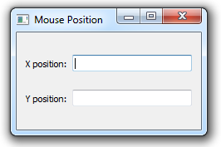

Tasks
- Override required method to track mouse position. And implement it.

Detailed guidelines

Part 1: Tracking mouse position
- Open qt-07-events project.
- See what elements are here. What is needed?
- First, to track mouse position you should turn on a mouse tracking. You can do it in constructor:
this->setMouseTracking(true);
- To receive this event you have to reimplement method:
void QWidget::mouseMoveEvent(QMouseEvent *event)
- Get mouse position:
int xPosition = event->pos().x();
int yPosition = event->pos().y();
- And set text of line edits. What you need to do it?
findChild<QLineEdit *>("xLineEdit")
->setText(QString::number(xPosition));
findChild<QLineEdit *>("yLineEdit")
->setText(QString::number(yPosition));
- Run your application. Check that mouse position is changed.
- Why text is not changing when mouse is on line edits?

Exercise 8
Qt Dialogs

Project
qt-08-dialogs

Duration
30 min

Objectives
Learn how to use standard Qt dialogs.

Description
Qt provides powerful classes to get a user choice using dialogs.

Tasks
- Use QMessageBox to show any text.
- Use QInputDialog to ask user an integer number. Show user input in the line edit.
(optional) Change line edit for QInputDialog only if OK button is pressed.
- Use QFileDialog to ask user for an existing file. Show user input in the line edit.
(optional) Specify the mask for displaying files: *.txt.
- Use QColorDialog to ask user for color. Show user input in the line edit.

Detailed guidelines

Part 1: Using QMessageBox
- Simple call QMessageBox::information in required method in mainwidget.cpp. Use other parameters to specify window title, message and button:
QMessageBox::information(
this, "Hello", "Hello World!", QMessageBox::Ok
);
- Don’t forget about include directive:
#include <QMessageBox>
- Run your application; check the result.

Part 2: Using QInputDialog
- QInputDialog provides functions to get simple user input such int, double or QString.
- Add include directive:
#include <QInputDialog>
- Call QInputDialog::getInt and specify required paramters:
int result = QInputDialog::getInt(this, "Value input", "Please input integer");
- Change content of line edit:
findChild<QLineEdit *>("integerLineEdit")
->setText(QString::number(result));
- Run your application. Check this button.
- (optional) Note that if user press CANCEL button, then zero is displayed. You can change the line edit only if user press OK button. See arguments list for it.

Part 3: Using QFileDialog
- QFileDialog is in Qt Widgets module. Add this for using QFileDialog:
QT += widgets
- Add include directive for this dialog:
#include <QFileDialog>
- Simple call QFileDialog::getOpenFileName(this):
QString fileName = QFileDialog::getOpenFileName(this);
- And set content of the required line edit:
findChild<QLineEdit *>("fileLineEdit")
->setText(fileName);
- (option) Note that you can specify mask for file to select. Specify *.txt mask.

Part 4: Using QFileDialog
- QColorDialog is in Qt Widgets module too:
QT += widgets
- Add include directive for this dialog:
#include <QColorDialog>
- Simple call:
QColor color = QColorDialog::getColor();
- Note that the parent widget is not required here.
- And set content of the required line edit:
findChild<QLineEdit *>("colorLineEdit")
->setText(color.name());

Exercise 9
OS Features

Project
qt-09-os-features

Duration
1 h 30 m

Objectives
Learn how to use OS features like registry, threads and cross-platform output.

Description
Any application can store its settings in system registry. The problem is that each operating system has its own registry format. Qt provides cross-platform classes for working with registry.
The same situation with threads, synchronization and binary files format (it depends on an endiannes).
In this exercise you have to create application that converts text data to cross-platform data, using threads.

Tasks
- Create the text data reader (QTextStream).
- Create the data writer (QDataStream), connect it to the reader.
- Create threads for the reader and the writer. Attach these objects to required threads.
- (optional) Save selected user files to the registry, and read it when application starts.

Detailed guidelines
Part 1: Data reader
- Open project. Run it. What classes and forms are here?
- Open textstreamreader.h. What methods and signals are here? Open textstreamwriter.cpp.
- Let’s implement readFrom file method. Open file for reading:
QFile file(fileName);
file.open(QIODevice::ReadOnly);
- Create QTextStream:
QTextStream stream(&file);
- Read each row from file:
QString line = stream.readLine();
if (line.isNull() || line.isEmpty()) {
break;
}
double data = line.toDouble();
qDebug() << "Read" << data;
emit dataReaded(data);
- Run application; specify qt-09-os-features\data.txt file and test that the reader works.
Part 2: Data writer
- Open datastreamwriter.h. What is needed to be implemented? Open textstreamwriter.cpp.
- Create and open given file, create QDataStream in constructor:
file = new QFile(fileName);
file->open(QIODevice::WriteOnly);
stream = new QDataStream(file);
- Delete these objects in destructor:
delete stream;
delete file;
- Implement data writing:
*stream << data;
qDebug() << "Write" << data;
- Connect reader and writer. Note that you can destroy these objects using the signals and slots mechanism:
connect(reader, &TextStreamReader::dataReaded,
writer, &DataStreamWriter::writeData);
connect(reader, &TextStreamReader::allDataReaded,
writer, &DataStreamWriter::deleteLater);
connect(reader, &TextStreamReader::allDataReaded,
reader, &DataStreamWriter::deleteLater);
- Run application, check that the writer works.
Part 3: Threads
- Open mainwidget.h. What fields need to be initialized?
- Open mainwidget.cpp, create and start these threads in constructor:
readerThread = new QThread;
writerThread = new QThread;
readerThread->start();
writerThread->start();
- Delete these threads in destructor:
delete readerThread;
delete writerThread;
- Move the reader and the writer to these threads:
reader->moveToThread(readerThread);
writer->moveToThread(writerThread);
Part 4 (optional): Using system registry to store filenames
- Try to do it by yourself.

